Market Research and Competitive Analysis of the Smart
Parking Management Systems

Phase 3: Primary Research

Kumar Shashank
Brown University
for
Professor: Dr. Ja-Nae Duane, Ph.D., M.M., EMBA


Problem Statement: What if drivers are offered parking spots that are more affordable and secure, and parking providers are offered real-time dynamic parking pricing and a more reliable payment system?

Part 1 – Define Target Respondents

According to the Primary and Secondary Research that I conducted, the following are the top 5 stakeholders associated with my problem statement while accessing a sustainable solution:
Stakeholder | Relevance
Daily Commuters | Frequent users of street or lot parking — high frustration, behavior-driven insights
Apartment Residents | Have long-term needs; care about security, consistency
Garage Managers | Know occupancy trends, pricing tactics, and system flaws
City Planners | Care about infrastructure impact, enforcement, data
NYC Municipality | Gatekeepers of policy, pilot approvals, public expectations

Part 2 – Develop Survey/Questionnaire

After rigorous brainstorming, the following questions were developed to perform a Bias-Free Survey/Questionnaire environment:
Experience
- “How often do you have trouble finding a parking spot?”
- “Where do you usually park — street, garage, private lot?”
- “On average, how much time do you spend looking for parking?”
Value Perception
- “Would you pay extra for parking that is secure and monitored?”
- “What would make a parking spot feel safe and convenient for you?”
Tech Adoption
- “Have you used any parking apps? If yes, what was your experience?”
- “What are 2–3 must-have features in a parking app or system?”
Pain Points
- “What challenges do you regularly face while parking?”
- “Are there areas or times when parking becomes particularly frustrating?”
Pricing Sensitivity
- “What’s the maximum extra amount you'd be willing to pay for a guaranteed spot during busy hours?”
- “Would a pay-per-minute model, flat fee, or dynamic pricing feel most fair to you?”
Future Outlook
- “If a device automatically verified your parking and charged you securely, how would that change your experience?”
Link to the survey: Link

Part 3 – Results of the Primary Research

Category | Common Response | Stakeholder | Targeted Area | Insights
Pain Point | “I don’t feel safe parking in dim garages near my home” | Resident | Safety, Location | Emotional blocker to adoption
Feature Need | “It would help to know if a spot is truly empty before arriving” | Commuter | Realtime, Availability | Feature Priority
Behavior Trigger | “If I could pre-book, I’d happily pay $5 to skip circling” | Commuter | Prebook, Willingness | Price Sensitivity Insights
System Friction | “It’s frustrating when one app works for one garage but not another” | Commuter | Fragmentation | Platform Opportunity (Aggregation)
Policy Barrier | “We need pilot tech to comply with ADA and privacy code” | NYC Municipality/ City Planners | Compliance, Privacy | Legal and Stakeholder Framing
Visual Representation of Responses and Insights from the Research:
1)
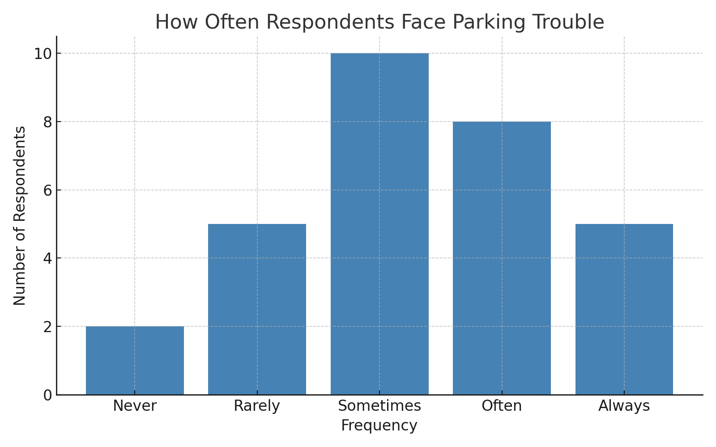
2)
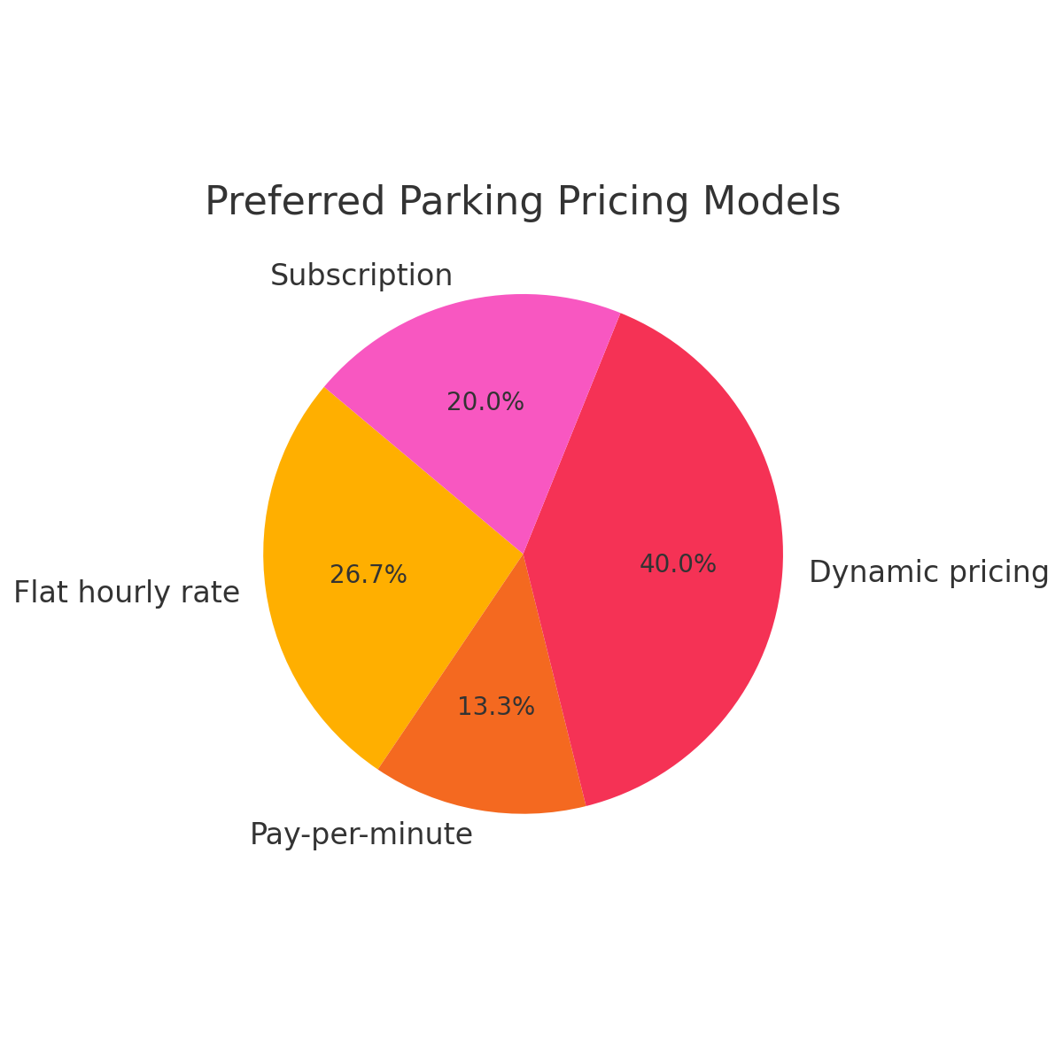
3)

